**TASK 2 - To Use Google Cloud Platform inorder to deploy an application**

**AIM –** To make use of Google App Engine in order to deploy an application/ Mobile Recharge Portal by the end user.

**PROCEDURE :**

**Step 1 :**

Open your browser and visit <https://console.cloud.google.com/>

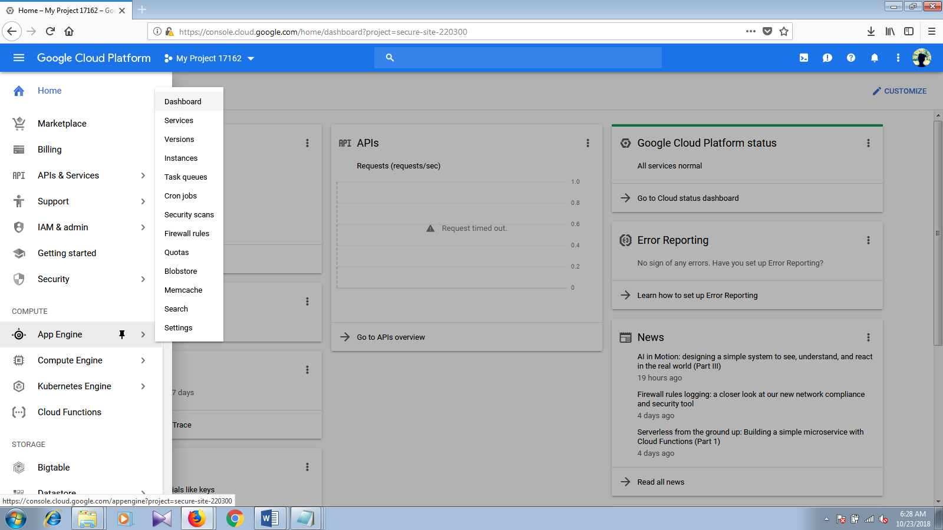

**Step 2 :**

Create new project after accepting terms of service corresponding to the app engine.

**Step 3:**

Select an interface language through which you want to develop the app(Java, Ruby, Python, php ect.)

**Step 4:**

Select a region from which you want your app to be served. The default region will be us-central( You may choose any among the available servers)

**Step 5 :**

If you are making use of app engine for the first time, it provides you with Appengine quick start that enable you to understand how to operate with the cloud. Following the instructions of quick start helps us to make use of hello world program which is already integrated with the cloud.

**Step 6 :**

The commands provided by the quick start are to be executed in the Cloud Shell as follows

talluriharika13@cse49-172206:~$TUTORIALDIR=~/src/cse49-172206/php_gae_quickstart-2017-06-29-12-14



talluriharika13@cse49-172206:~$ cd $TUTORIALDIR



talluriharika13@cse49-172206:~/src/cse49-172206/php_gae_quickstart-2017-06-29-12-14$ cat helloworld.php

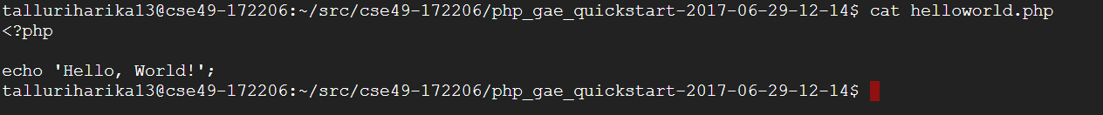

talluriharika13@cse49-172206:~/src/cse49-172206/php_gae_quickstart-2017-06-29-12-14$ cat app.yaml

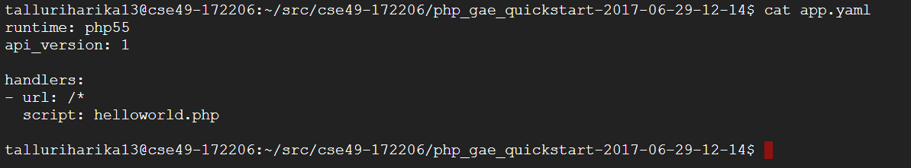

**Step 7:**

Now your helloworld program is ready and the final result can be viewed by selecting the option of web preview. We need select a port number to view the result. The default port is 8080.

**Working with the Google App Engine using HTML – PHP simple mobile recharge portal application**

**Step 1: PROGRAM :**

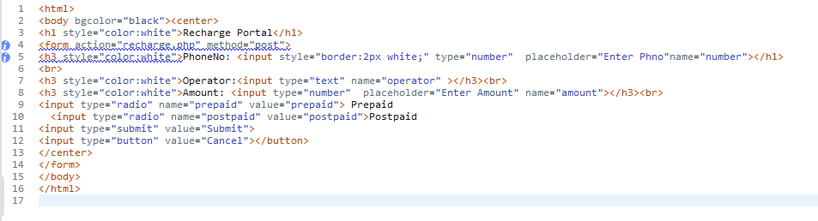

**Step 2:**

Create PHP file so that we can make use of it in order to validate the previously created HTML form

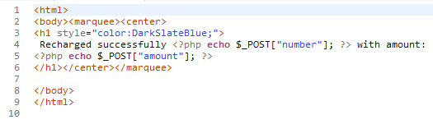

**Step 3:**

Since the two programs are ready, now we need to deploy the two programs into our project directory present in the cloud.

talluriharika13@cse49-172206:~/src/cse49-172206/php_gae_quickstart-2017-06-29-12-14$ gcloud app deploy app.yaml --project 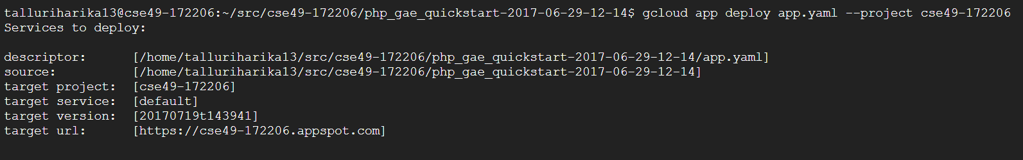

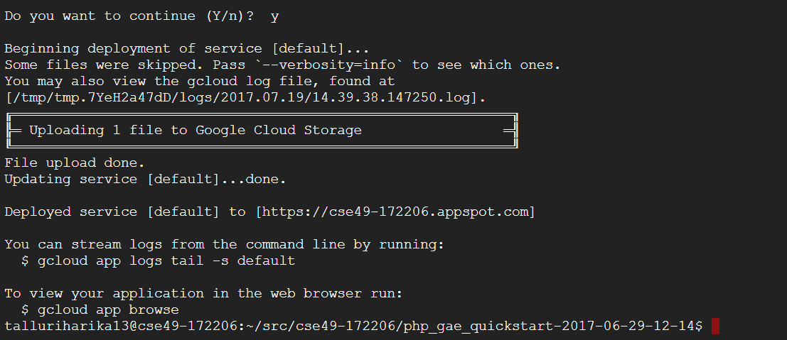

**Step 4:**

In order to run the application, we need to modify the app.yaml file as follows

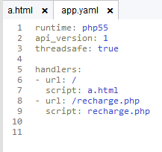

**Now we can open the recharge portal with the url provided by the App engine.**

[**https://project-recharge.appspot.com/**](https://project-recharge.appspot.com/)

**The portal looks as follows :**

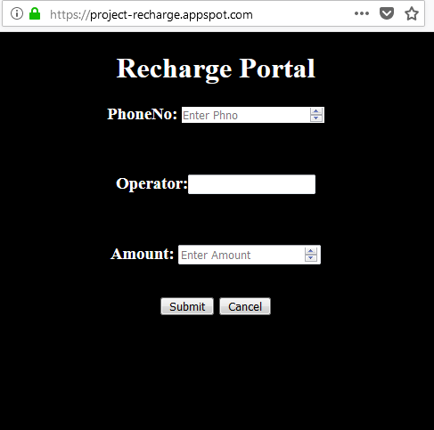

**When we enter the Phone No, Operator and Amount a message is been displayed as follows**

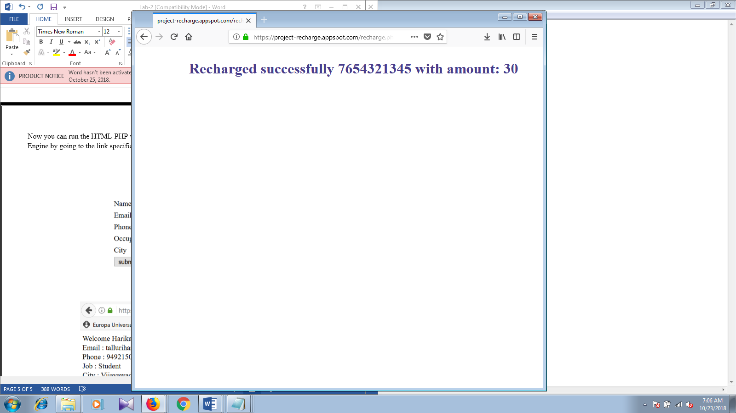

**RESULT** : Thus we have deployed a simple recharge portal using GoogleAppEngine Successfully**.**